NOC – Distillery

Login : Harinagar-Dis

1. NOC number should start from 1, starting from 7

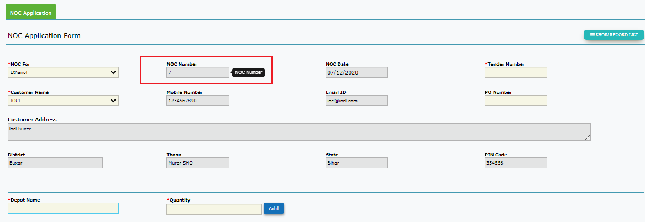

NOC Application List

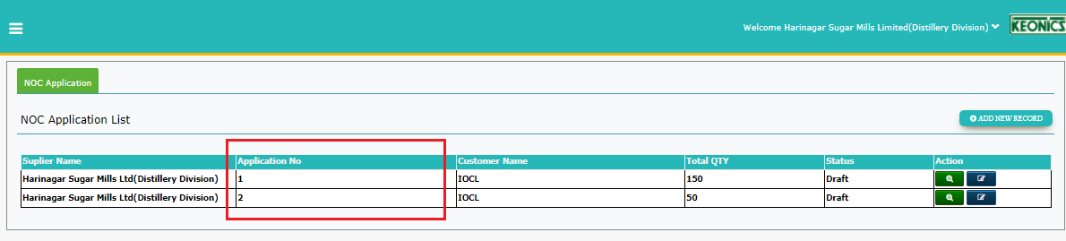

1. Application number is starting from 1 . Are NOC number and application numbers are different.

Expected: IT should be the same.

1. Unable view/ edit the first record getting

Server Error in '/IEMS_NEW' Application.

*Object reference not set to an instance of an object.*

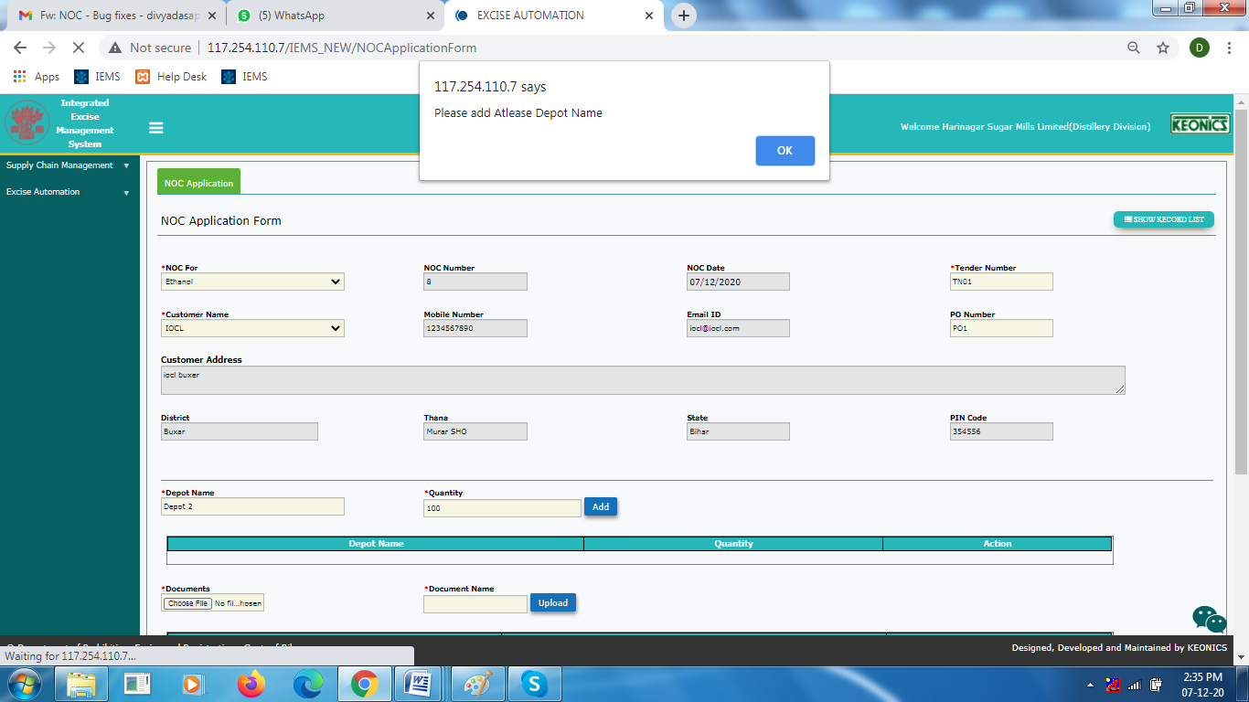2 UI- If user does not add the details to GRID and click on save/save as draft the below alert message is displayed. To be changed to “ Please click on ADD button to save the depot details” or as appropriately.

Alert Pop up

UI- “Please Upload atleat one Documents” to be changed to “Please attach documents”

WCEDO login

Wcedo – Rejected the Application – Approver Summary visible to only wcedo.DU cannot see the approval Summary.

Distillery Login

Approver comments not visible to DU(Distillery Unit)

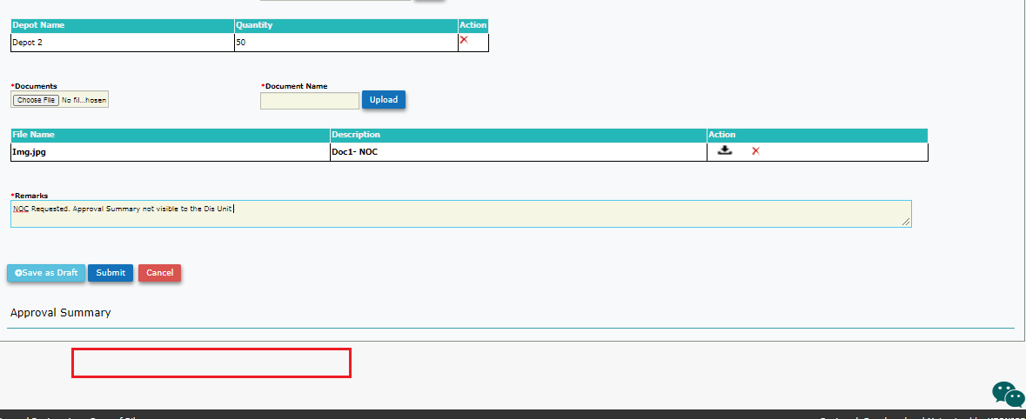Approval Summary should also be visible to Distillery Unit . But visible after DC rejection

**Hodyco**

Rejected , Status reflected for both AC and DU.

1. Should not be allowed to enter previous dates as “Valid Upto date”
2. Once date is selected – not able to select date from calendar control as it is blank, But user can write manually Expected : dates should be visible in the calendar control

**Distillery Login**

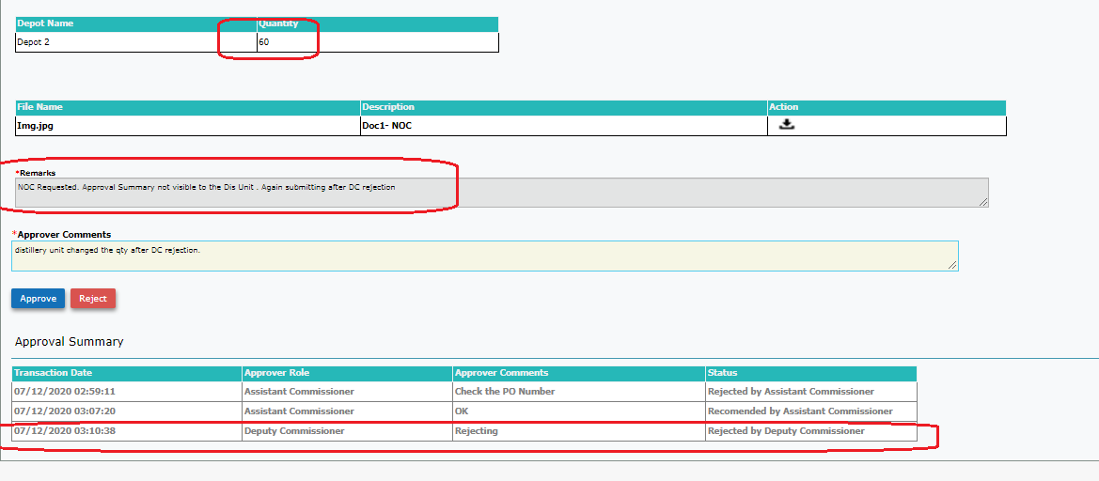Sc1:User changed the submitted NOC details and saved. Saved Details were refelected in levels of approval.

Once application is submitted and passes from AC to DC. Even if DC rejects Distillery Unit should not be allowed to change/ Edit the NOC details entered earlier.

**Expected:** AS soon as the NOC form is submitted and moved up to the authorities for approval, User should not be allowed to edit. **Submit and Save as draft button should get disabled or invisible**.

Submit or Save as draft button should again get enabled /visible only when AC rejects(Not When DC or Com rejects) . And get disabled once submitted.

**Commissioner Login**

Refer back with comments. Refer Back button working

**DC changes the date and Approved.**

1. But changed date is not reflected in COM login

**Ref below the approval summary for more details**

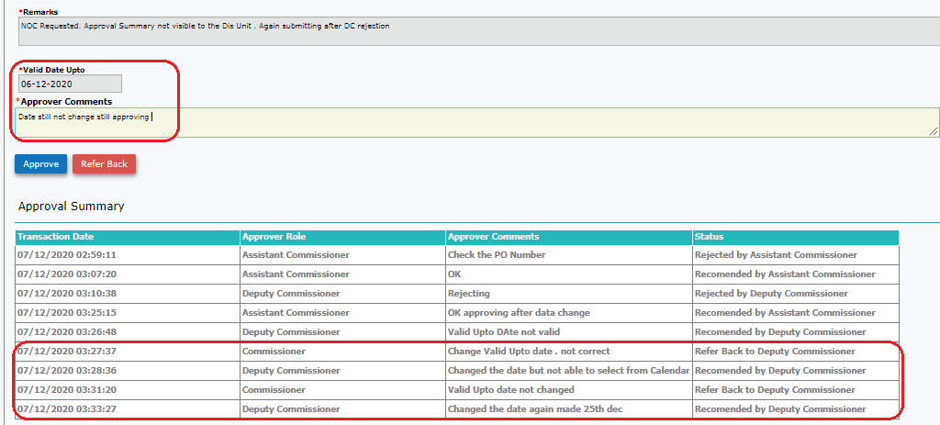

Hodyco - Issue

Issued and Print

When printed the NOC issued. Report is blank with only format and no data.

